**ARHINFUL EMMANUEL**

**RPA STUDIO FUNDAMENTALS**

1. Task: Creating and Initializing variables

* I designed a workflow and named the sequence Username
* I drag and drop the input dialog to the sequence and gave them title and label
* Inside the input dialog at the value entered portion I set a variable name “userName” and stored the user’s name.
* I then captured the user’s name and assigned it to the “userName” variable using the assign property in the activity field.

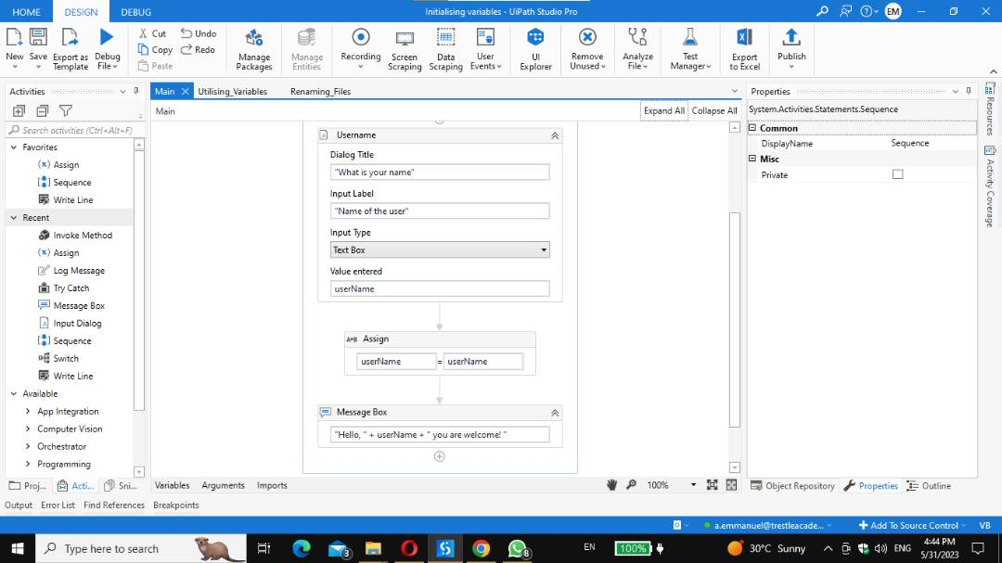

**Output:**

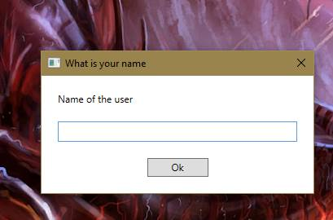

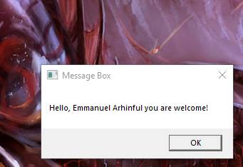

1. Task: Utilizing Variables in Automatic Logic.

* I designed a workflow that performs a simple calculation by adding two numbers “num1” and “num2”.
* The sequence name is “Utilizing_Variables”.
* I created two variable names “num1” and “num2”
* I dragged and dropped the assign and gave a variable name “num1” and assigned the value int32 "10” to it. I created a second assign and gave it a variable name “num2” with the value int32 “36”.
* I stored the result in a variable called “result”.
* Lastly, I displayed the result in the message box.

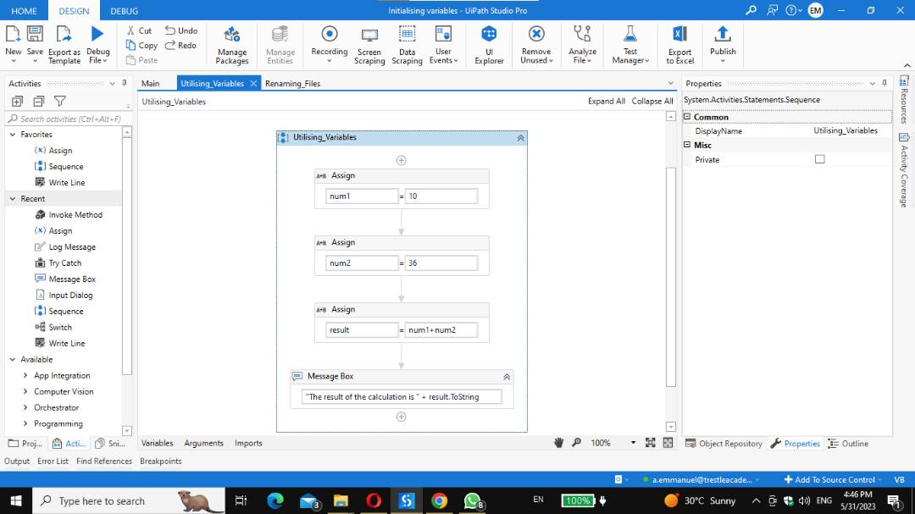

Output:

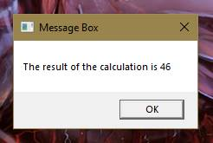

1. Task: Working with RPA concepts

* The workflow designed is to automate repetitive tasks like renaming a file.
* The first step is the try and catch block which displays error when the file is not found with the FileNotFoundException with the error log message.
* The try block contains the sequence with two assign properties in which the first assign I set the variable name to “Oldfile” and the value with the directory of where it is located whereas the second assign is set with the variable name “Newfile” and assigned the directory to where it should appear.
* Moreover, I used the Invoke Method and specified the target type (Microsoft.visualsbasic.fileSystem) and the method name to be “Rename”.
* At the invoke method parameters I specified the variable names.

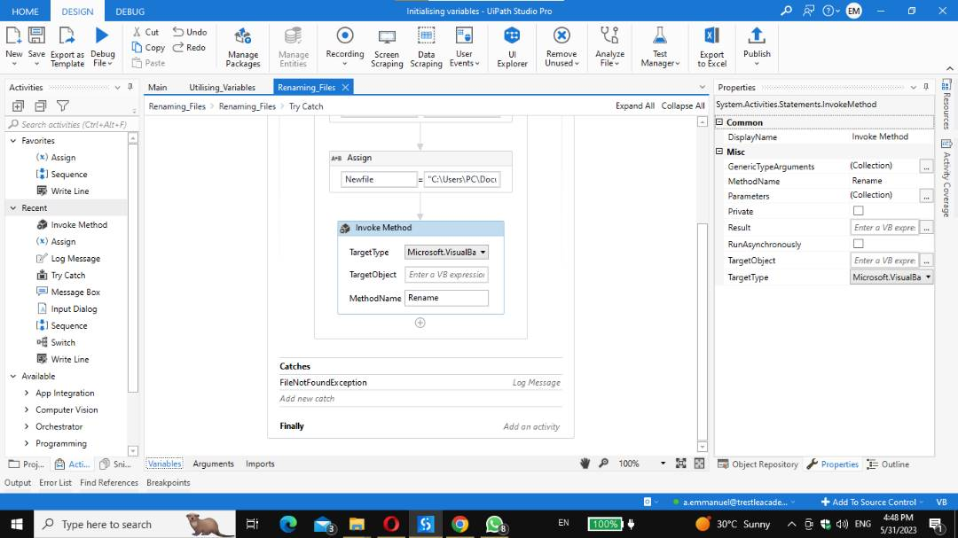 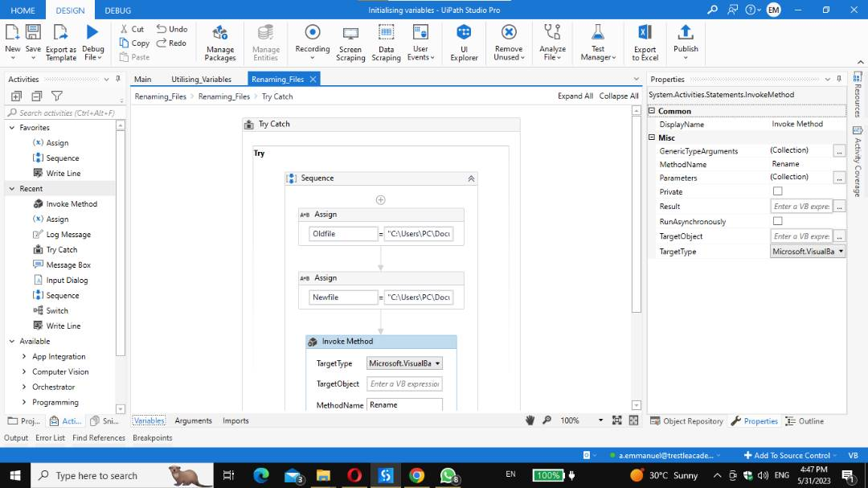

Output:

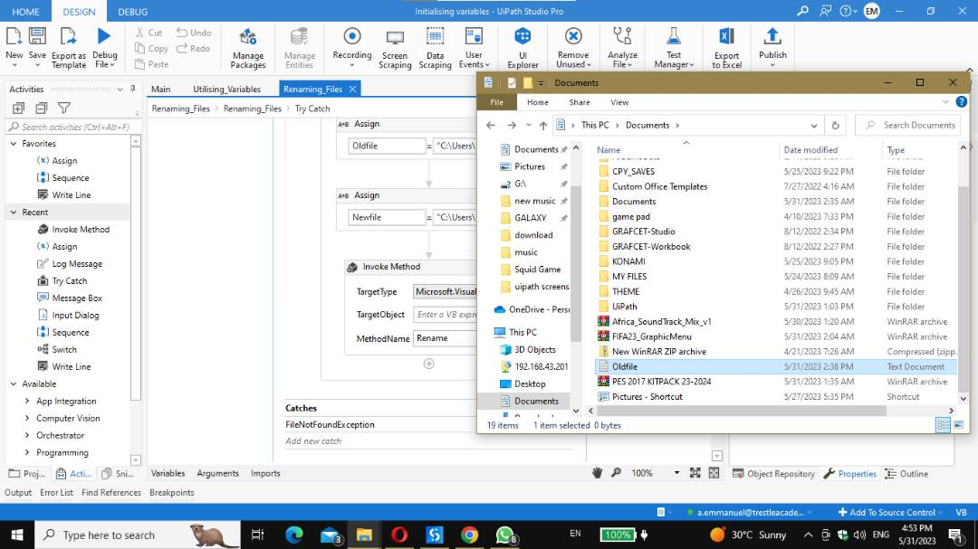

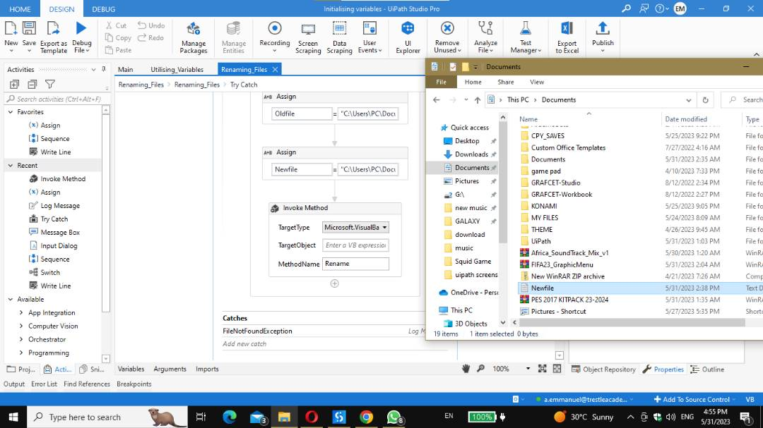

CHALLENGES

* In task1 after designing the workflow I had system.Exception error I found solution to the error (antivirus on the pc blocked it form executing) execution of workflow was successful after disabling it.

